# **Exercise 1 - Managing the Windows 11 Startup Folder**

The Start menu's Startup folder provides shortcuts to apps that start automatically when a user logs in. This minimizes the time it takes for an application to respond.

When a program like anti-malware is installed or a multifunction device like a printer-scanner is added to Windows, several program shortcuts are automatically created in the startup folder for the user's convenience.

Although having some programs start automatically can be advantageous because application response time is significantly faster, there may be non-essential items in the start-up folder that can be uninstalled or disabled to improve Windows' system performance.

In this exercise,

1. Examine programs in Task Manager Startup
2. Add a custom batch file in Task Manager
3. Specify Programs to run on Windows Startup
4. Manage a faulty application

## **Topology**

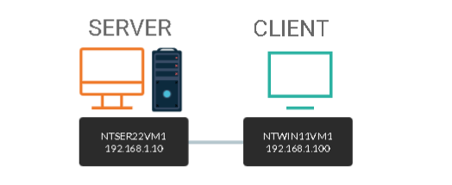

DOMAIN = networktute.com

NTSER22VM1 = Windows Server 2022 – Domain Controller

NTWIN11VM1 = Windows 11 – Domain Member

## **Prerequisite**

* *VMware Workstation 16 Pro*
  + When making this tutorial, we used the “Windows Server 2019” VM Template and “Windows 10 & later” VM Template. Since VMware didn’t have the updated templates.
* *Microsoft Windows Server 2022*
* *Microsoft Windows 11*

## **Task 1:**

When a user logs into Windows 11, several programs start up immediately.

Malware is stopped by programs like Windows Defender, which prevents system instability. As Windows 11 updates are released, new applications may find their way into the Startup folder.

If you suspect that applications in the Startup folder are causing a bottleneck that slows user sign in to Windows 11, you can turn them off to improve system performance.

Now let’s, locate the programs available that automatically start up using Task Manager.

**Step 1:**

Ensure you are connected to **NTWIN11VM1**

Right-click the **Start** and select **Task Manager**.

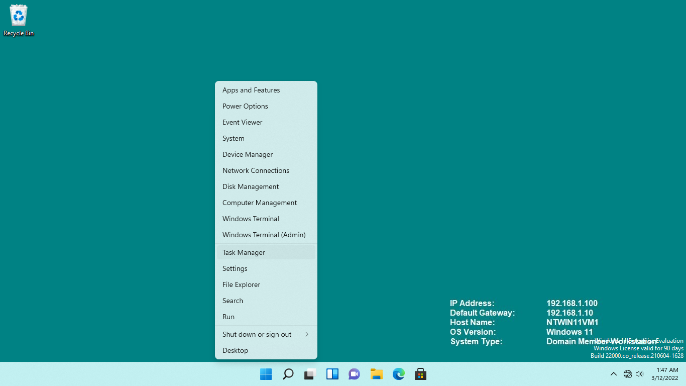

**Step 2:**

From the **Task Manager** window, click **More details**.

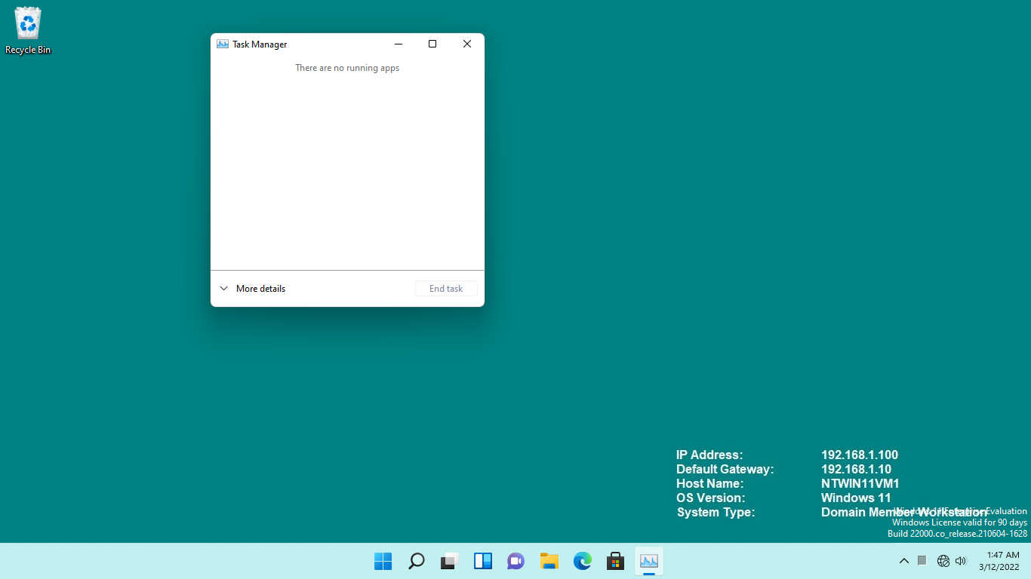

**Step 3:**

Click the **Startup** tab.

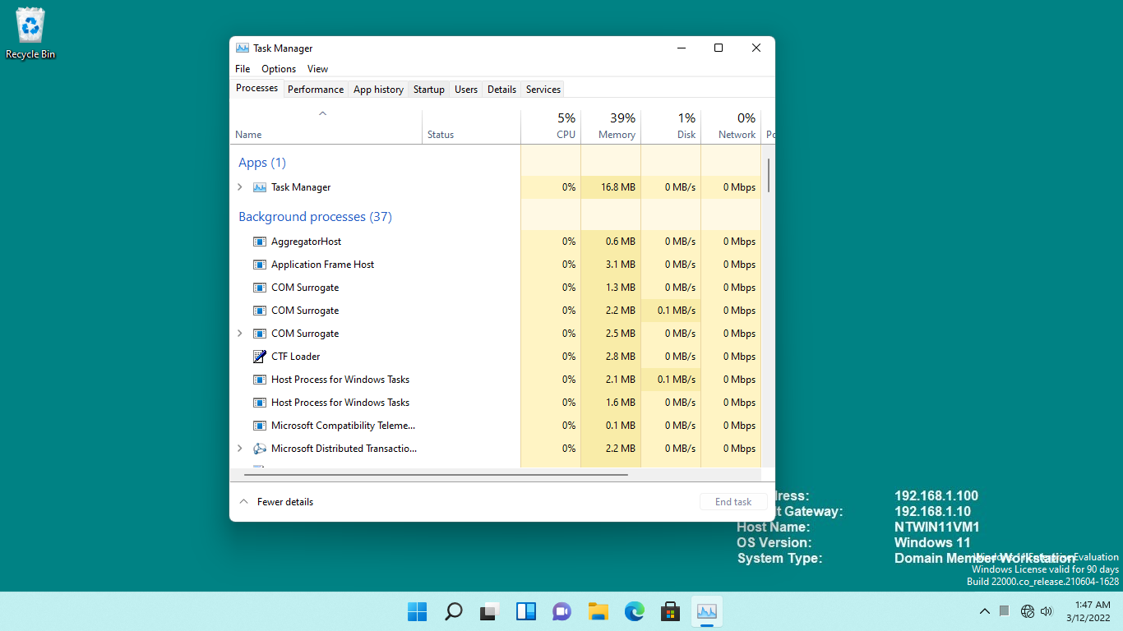

**Step 4:**

On the **Startup t**ab, take note of the list of programs that will automatically start upon sign in to Windows.

Close the **Task Manager** window.

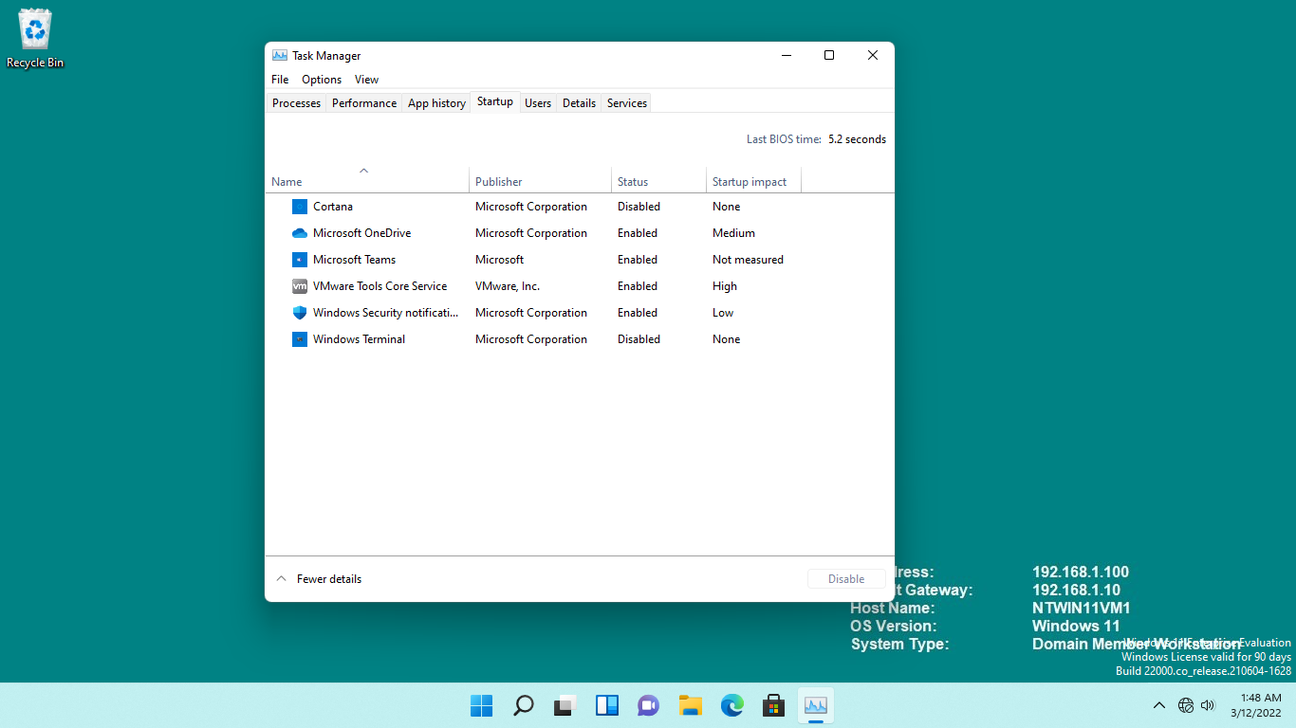

## **Task 2:**

Typically, vendors place programs in the Startup folder to ensure that their product runs properly after logging in.

Now let’s, add a batch file to display text as Windows 11 starts up.

**Step 1:**

Ensure you are connected to **NTWIN11VM1**.

Click into the **Search** box and type: ***regedit***

Press **Enter**.

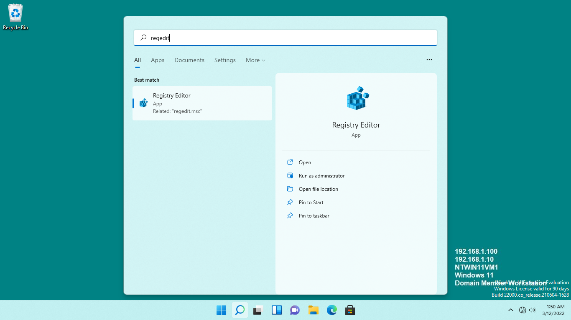

**Step 2:**

On the **Registry Editor** window, at the top of the left-hand pane, expand **HKEY_LOCAL_MACHINE > SOFTWARE > Microsoft > Windows > CurrentVersion > Run.**

Right-click on any whitespace on the right-hand details pane, point to **New**, then select **String Value**.

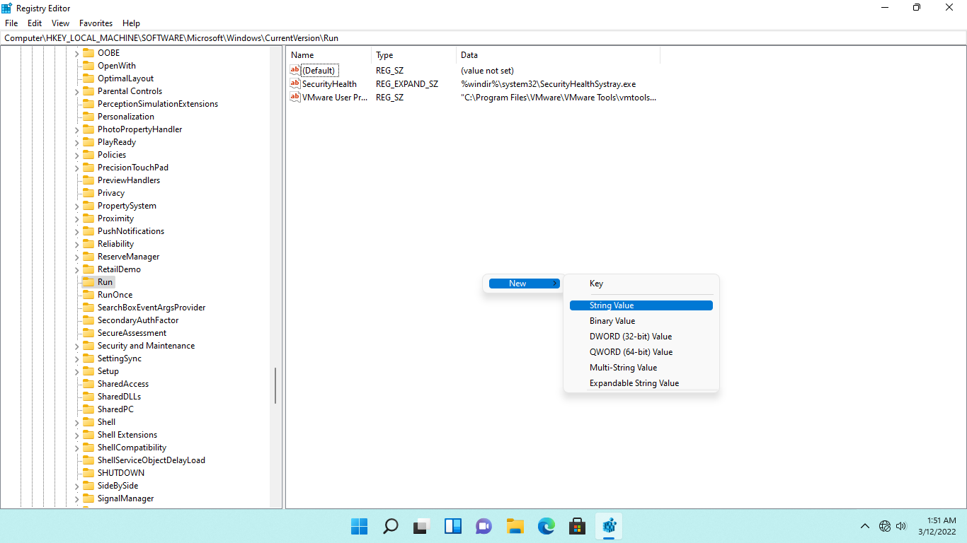

**Step 3:**

Type-over the **New Value #1** title with the following: ***1***

Press **Enter**.

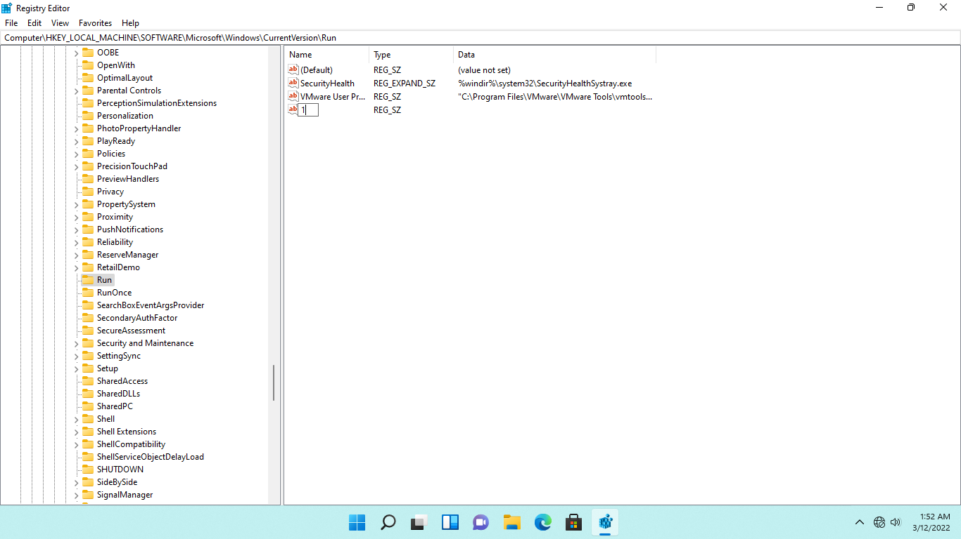

**Step 4:**

Right-click **1** and select **Modify**

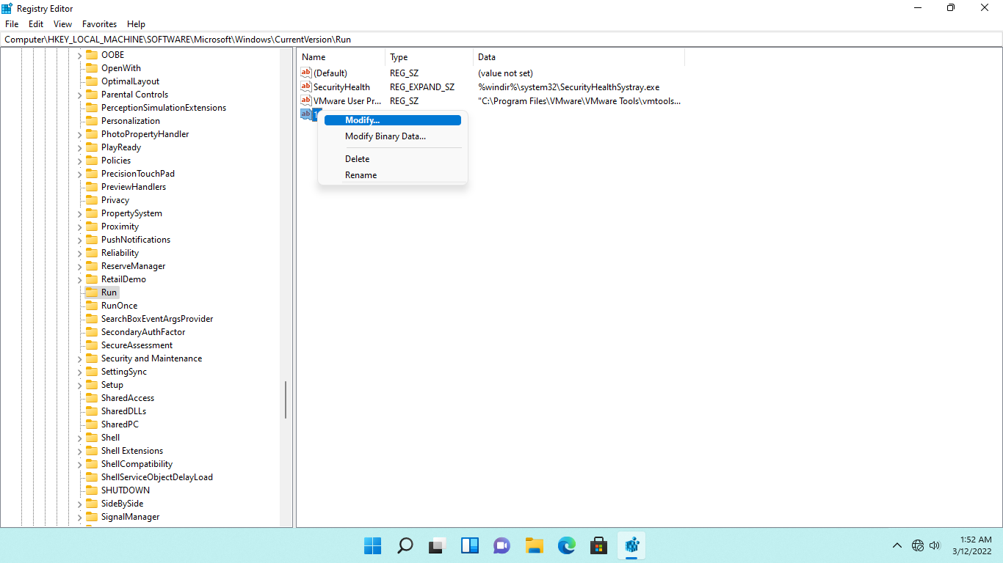

**Step 5:**

On the **Edit String** dialog box, type the following in the **Value data** textbox: ***c:\Windows\test.bat***

This specifies the path where the startup file is available. Click **OK.**

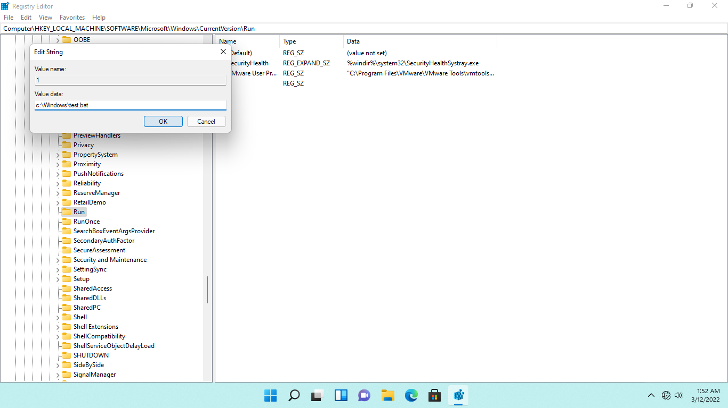

**Step 6:**

Close the **Registry Editor** window.

Click **File Explorer** on the **Taskbar** to start creating a sample batch file using the file name and path indicated in the earlier step.

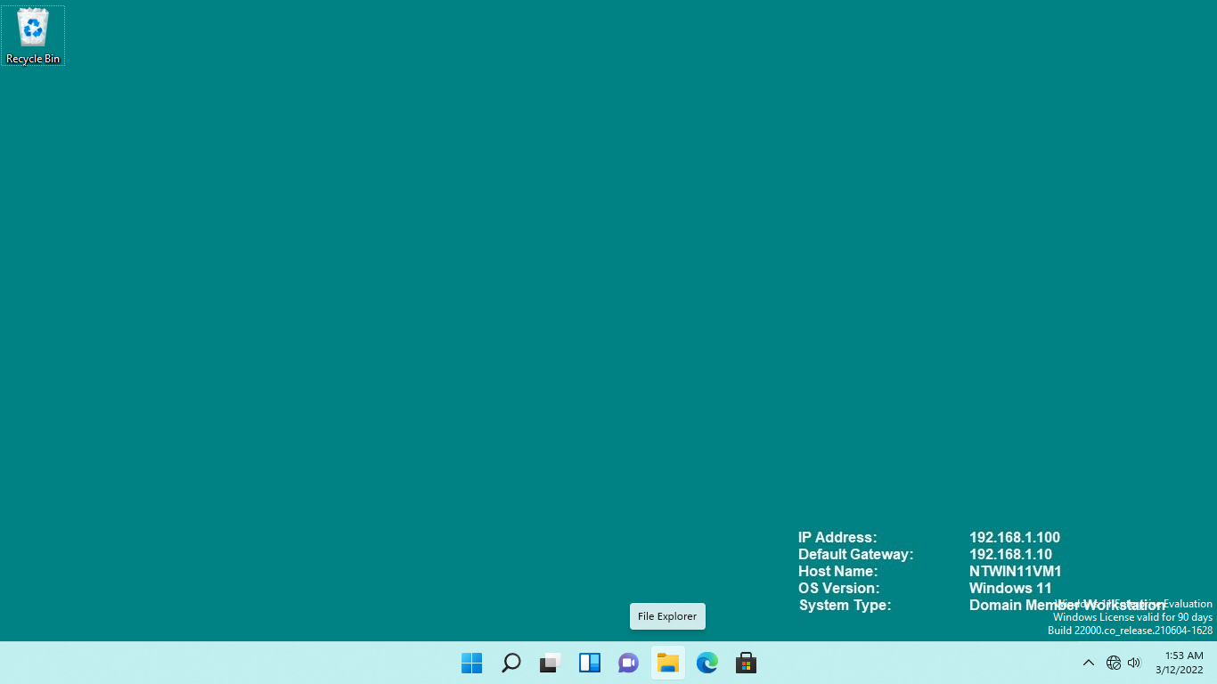

**Step 7:**

Click the **See more** tab near **View**.

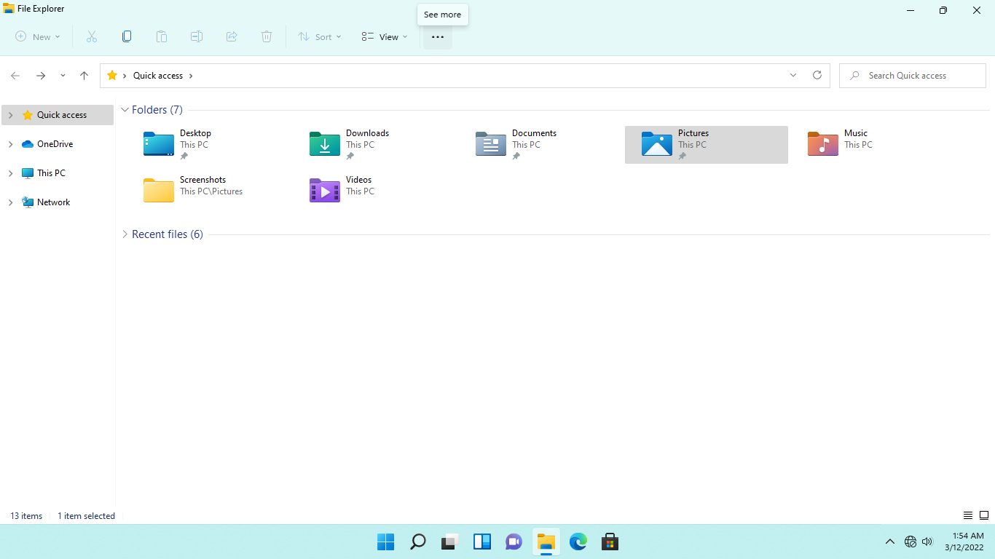

**Step 8:**

From the **See more** ribbon, click the **Options** dropdown arrow .

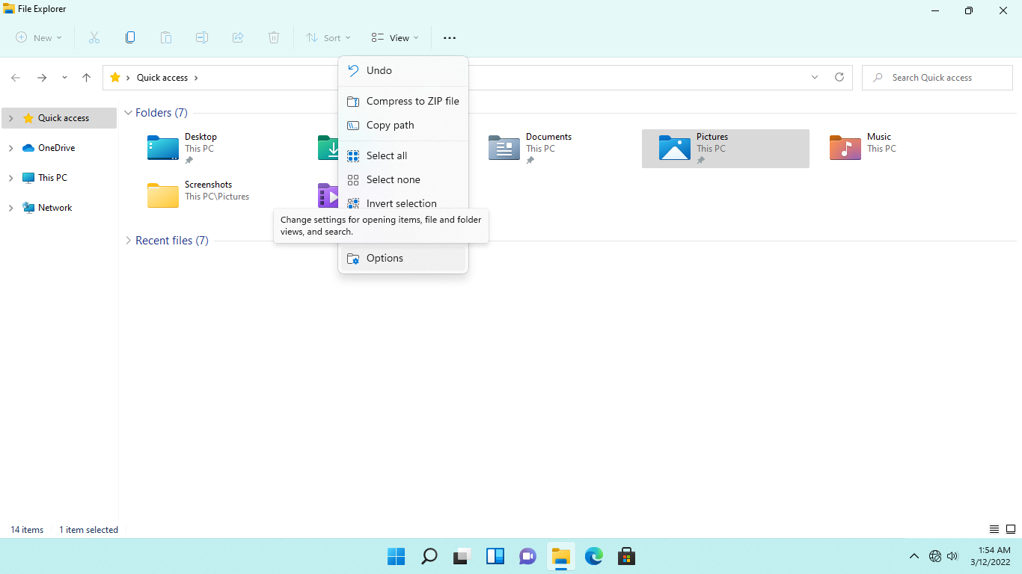

**Step 9:**

On the **Folder Options** dialog box, click the **View** tab.

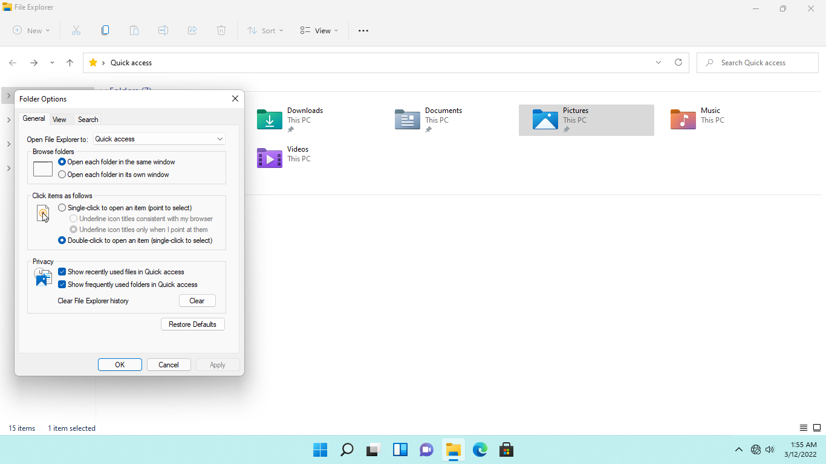

**Step 10:**

From the **View** tab, under the **Advanced settings** section, untick **Hide extensions for known file types** box. Click **OK.**

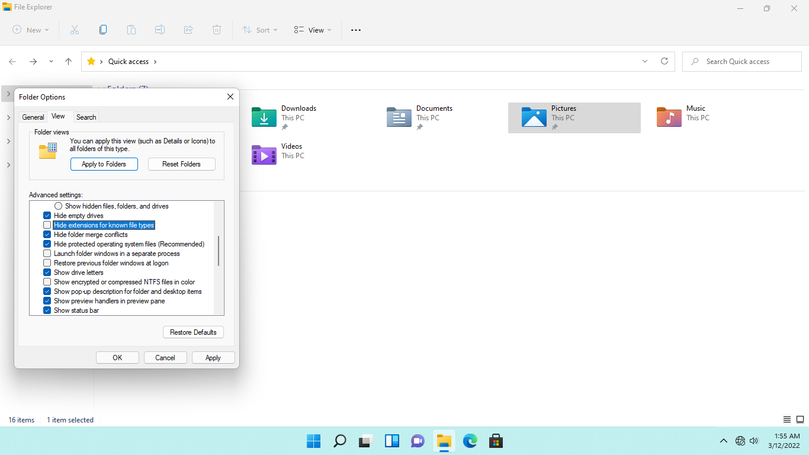

**Step 11:**

Back in **File Explorer**, expand **This PC > Local Disk (C:)**, then click the **Windows** folder.

On the right-hand details pane, right-click on any of the white space, point to **New** and select **Text Document**

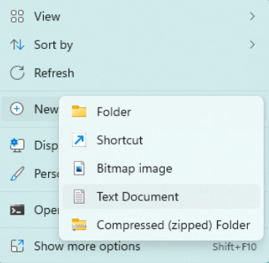

**Step 12:**

Delete the name **New Text Document.txt** and replace it with: ***test.bat***

Ensure that the “**.txt**” extension name is removed as well.

Press **Enter**.

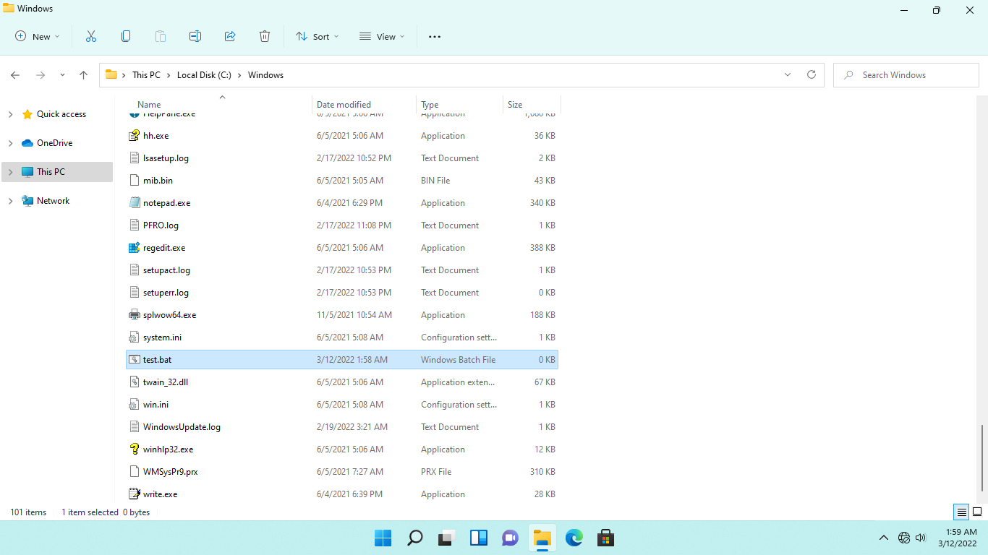

**Step 13:**

On the message box warning you about the change in extension name, click Yes to proceed

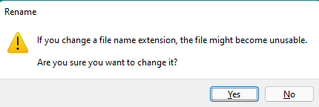

**Step 14:**

Now, right-click **test.bat** click **show more option** and select **Edit**.

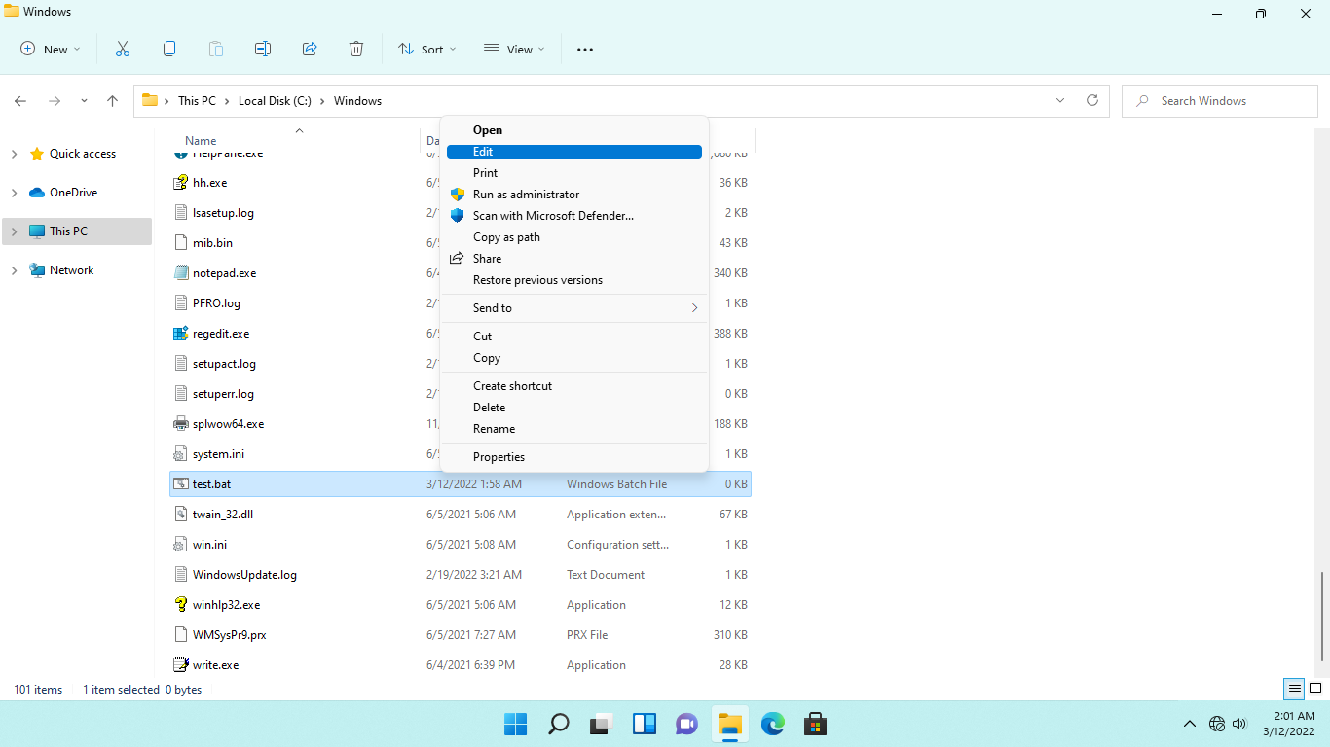

**Step 15:**

On the test.bat - Notepad window, type the following statement; you need to press Enter after each line:

|  |
| --- |
| @echo off |

|  |
| --- |
| echo “This is a sample batch file included in the Task Manager Startup folder.” |

|  |
| --- |
| pause |

Click **File** and select **Save** to save changes. Close **test.bat - Notepad**

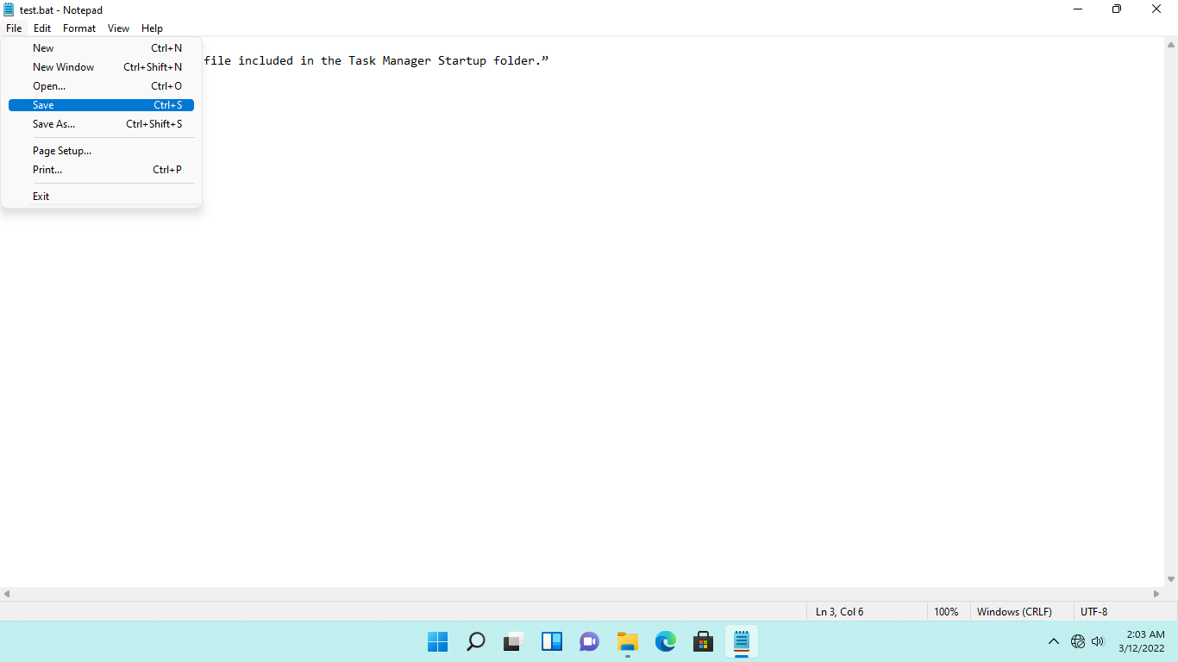

**Step 16:**

Close the **File Explorer** window.

To test the batch file, you must sign out of the current session.

Right-click the **Start** icon, click the **profile** and select **Sign out.**

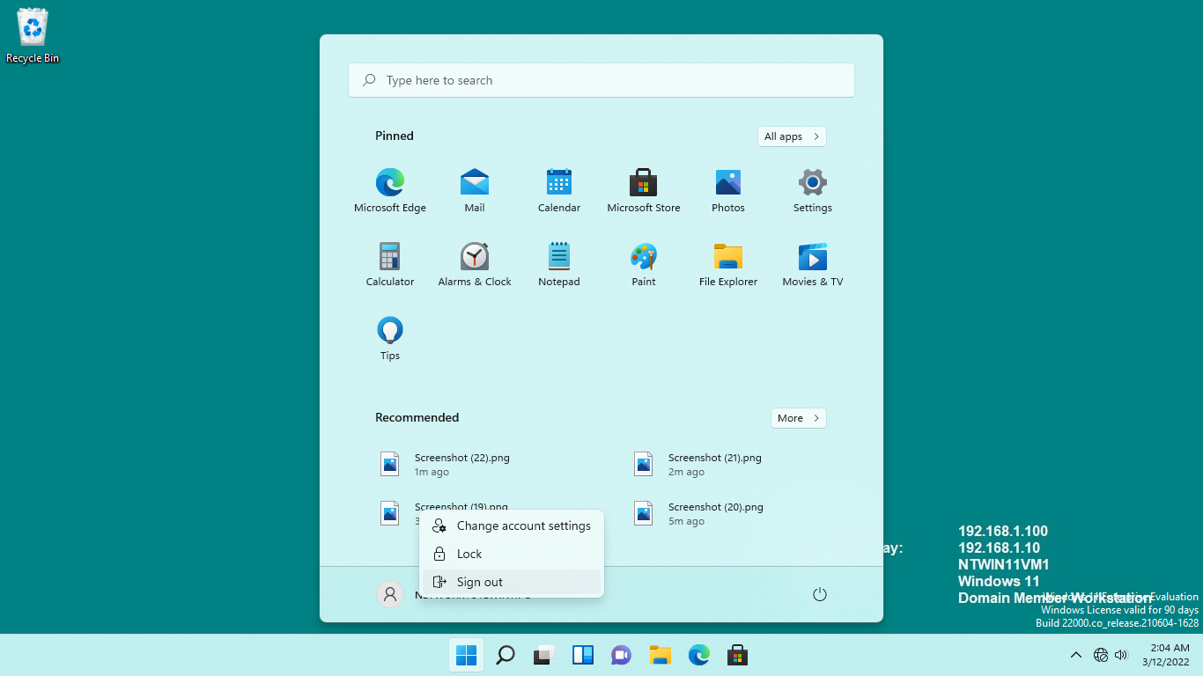

**Step 17:**

Reconnect to **NTWIN11VM1**.

You will be signed in automatically as the **Networktute\administrator** user in **NTWIN11VM1**.

After a few moments, the batch file created earlier will display in the command prompt window.

Press any key to dismiss the batch file.

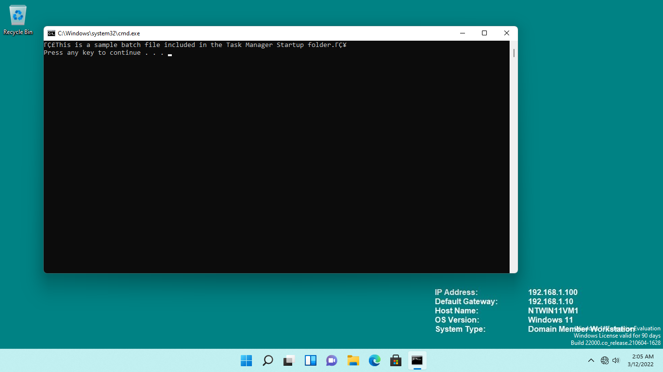

## **Task 3:**

Startup folders come in two types, namely:

* Personal Startup - contains program shortcuts for a specific Windows user.
* Common Startup - applies to all users who sign in to the computer.

Vendors can add programs to the common folder so that their product is launched automatically whenever Windows is started. To speed up starting, you can want to uninstall any programs that aren't essential.

In this task, we will add program shortcuts to both personal and common Startup folders.

**Step 1:**

Ensure you are connected to **NTWIN11VM1**.

Right-click the **Start** icon and select **Run.**

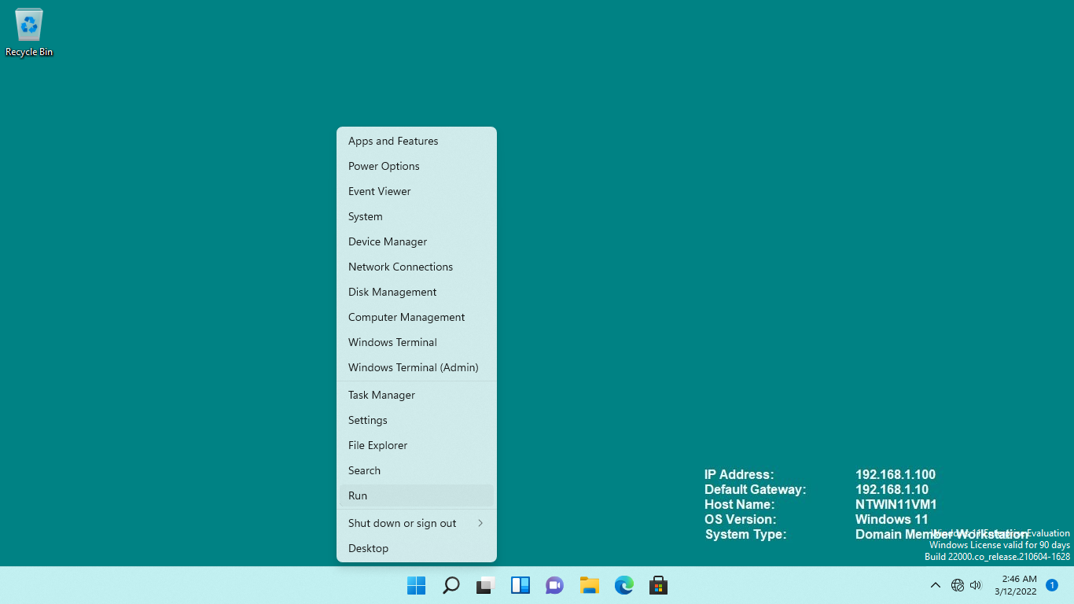

**Step 2:**

From the **Run** dialog box, type: ***shell:startup***

Press **OK**.

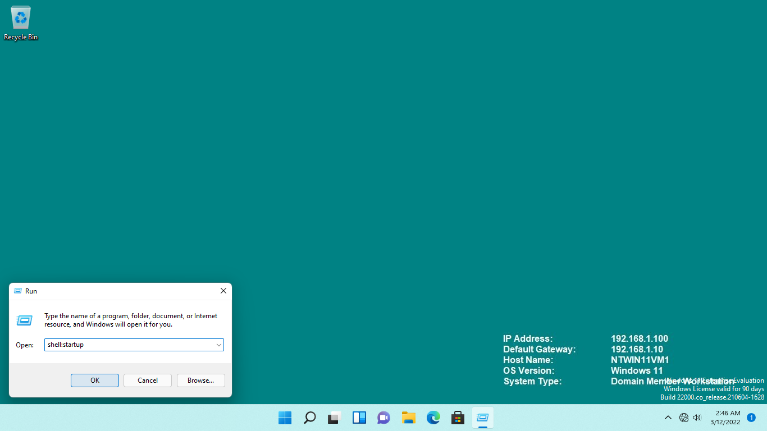

**Step 3:**

**File Explorer** opens and automatically redirects you to the **Administrator** path of the Startup folder.

On the right-hand details pane, right-click on any of the white space, point to **New**, then select **Shortcut**.

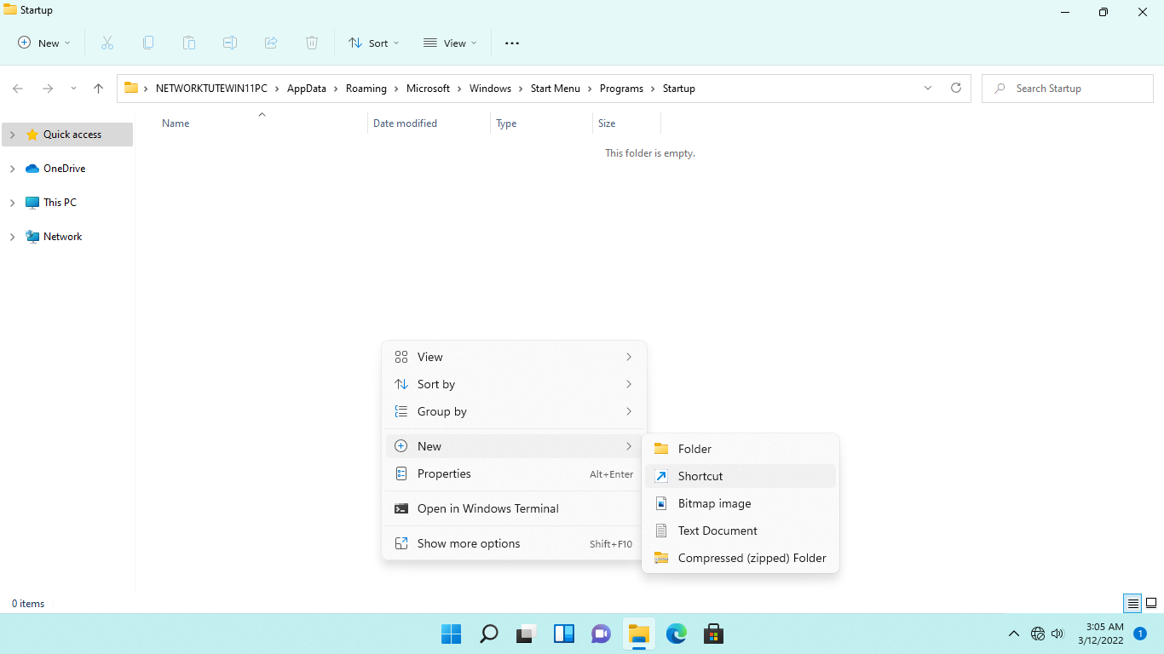

**Step 4:**

From the **Create Shortcut - What item would you like to create a shortcut** for, type the following path:

|  |
| --- |
| c:\Windows\notepad.exe |

Windows will auto-complete the path for you.

Click **Next**.

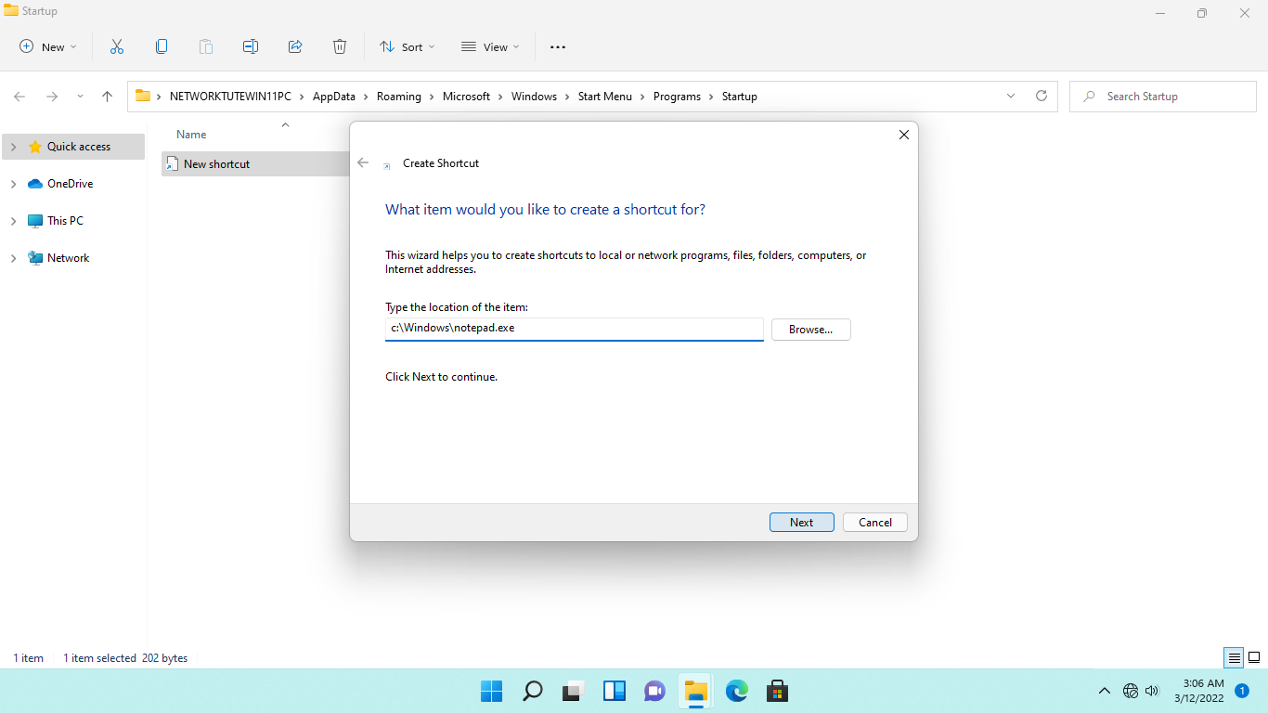

**Step 5:**

On the **What would you like to name the shortcut** page, keep the default name as notepad.exe and click **Finish**.

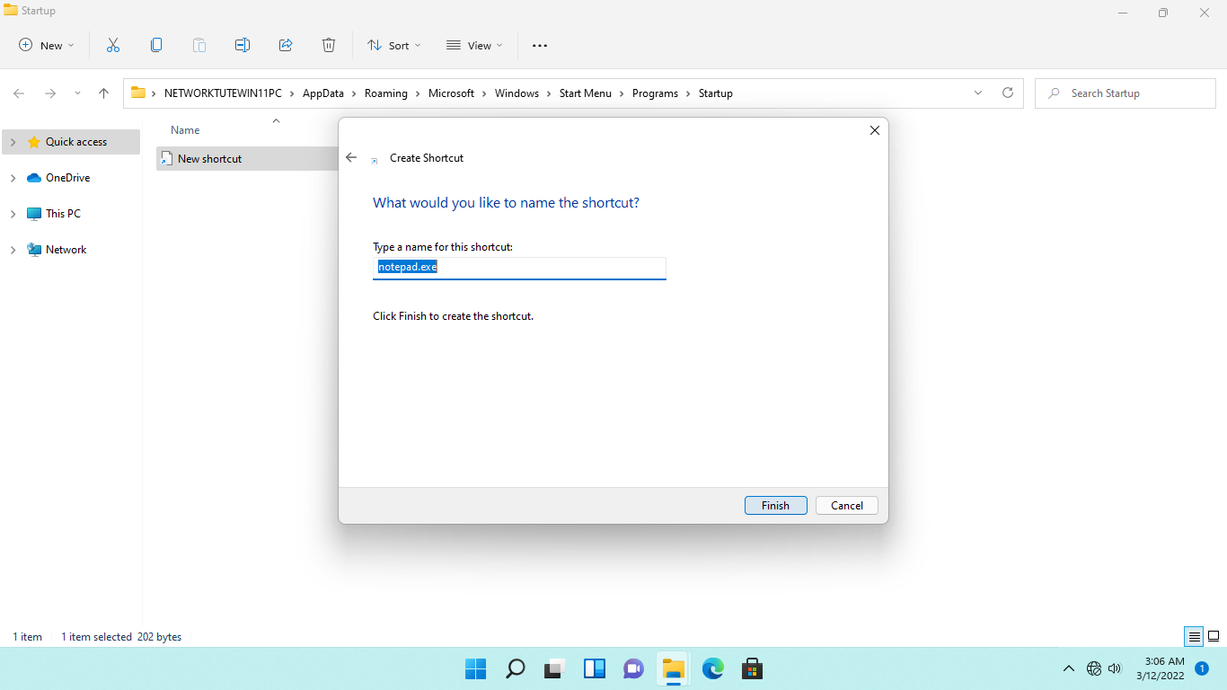

**Step 6:**

Right-click the **Start** icon and select **Run.**

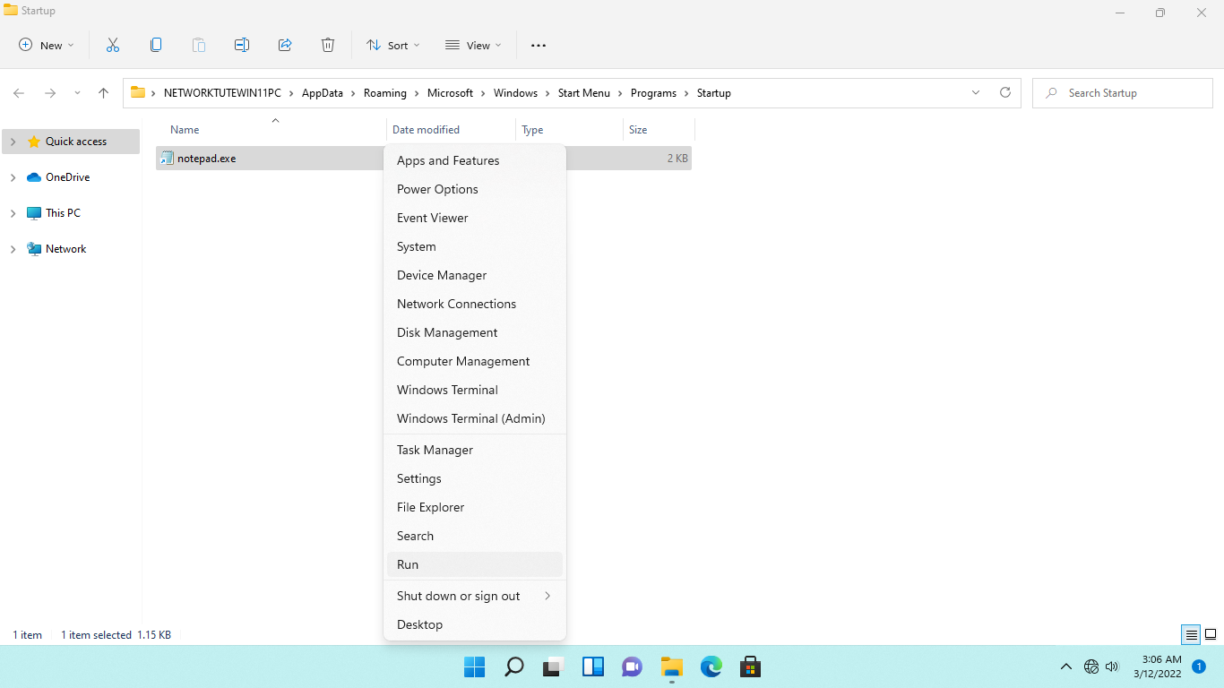

**Step 7:**

From the **Run** dialog box, type over the existing command with the following command to open the **Common Startup** folder: ***shell:common startup***

Press **OK**.

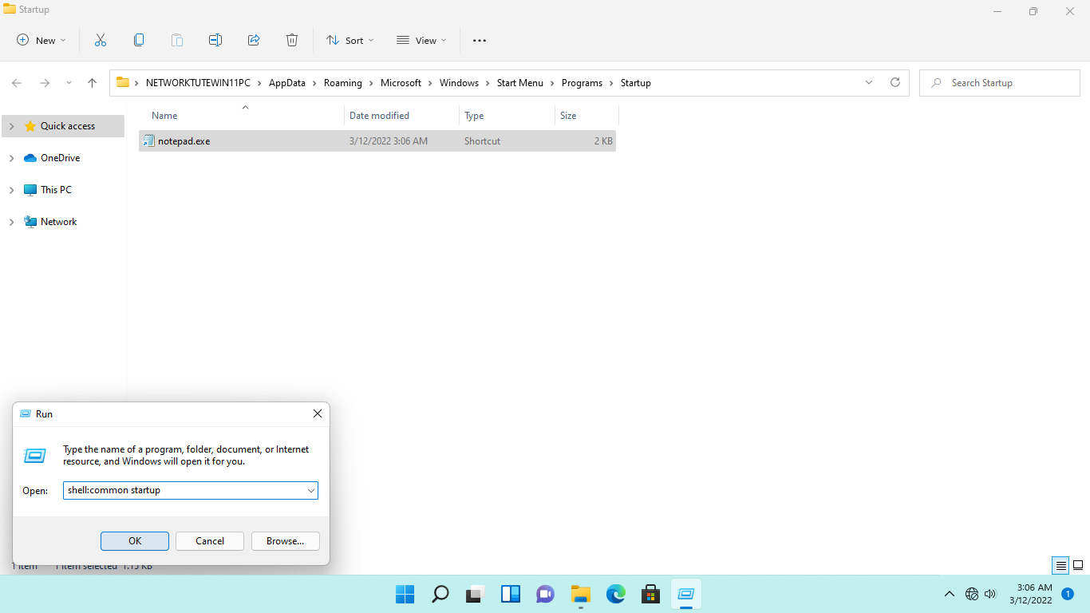

**Step 8:**

Another **File Explorer** window will open.

Notice that the program shortcuts of **Bginfo** and **Lab Device Client** are in the common **Startup** folder.

|  |
| --- |
| **Note**: Program shortcuts are references to Windows programs that are stored in the file system. Select **Open File Location** from the context menu when you right-click on one of the two shortcuts. |

On the right-hand details pane, right-click on any of the white space, point to **New**, then select **Shortcut**



**Step 9:**

As illustrated earlier, on the **Create Shortcut - What item would you like to create a shortcut for**, type the following path:

|  |
| --- |
| C:\Windows\system32\calc.exe |

Windows will auto-complete the path for you.

Click **Next**.

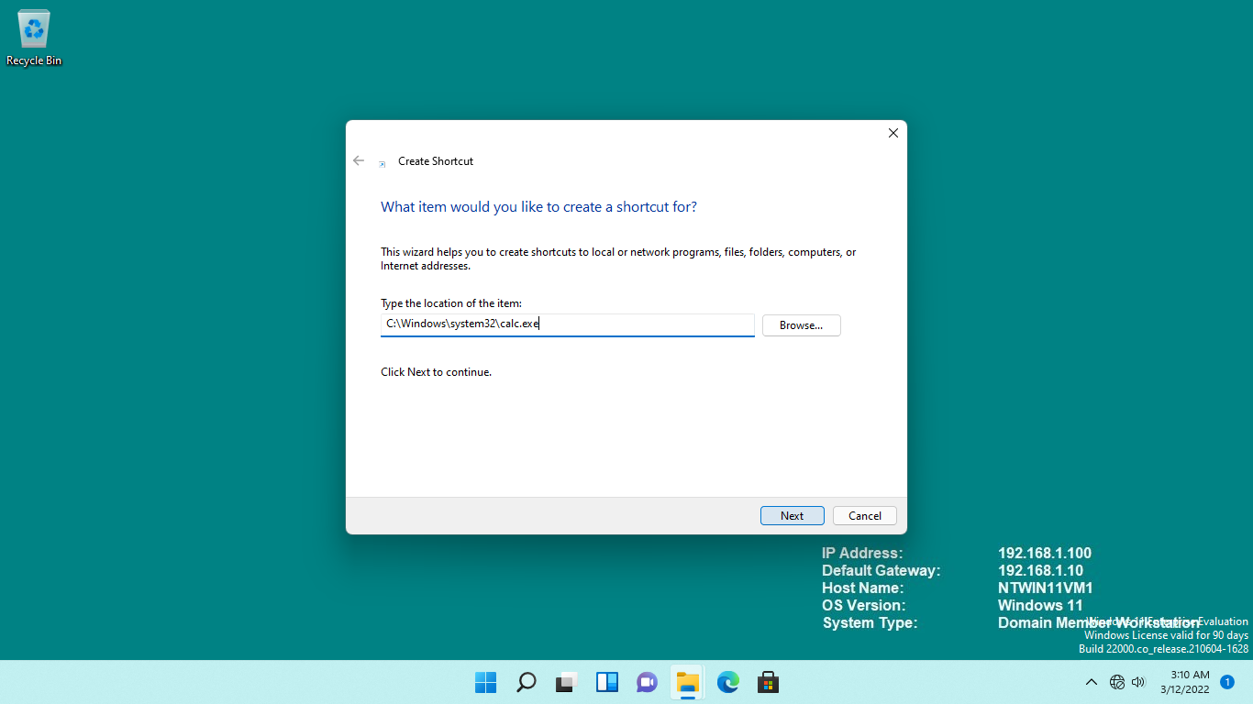

**Step 10:**

On the **What would you like to name the shortcut** page, keep the default name as calc.exe and click **Finish**.

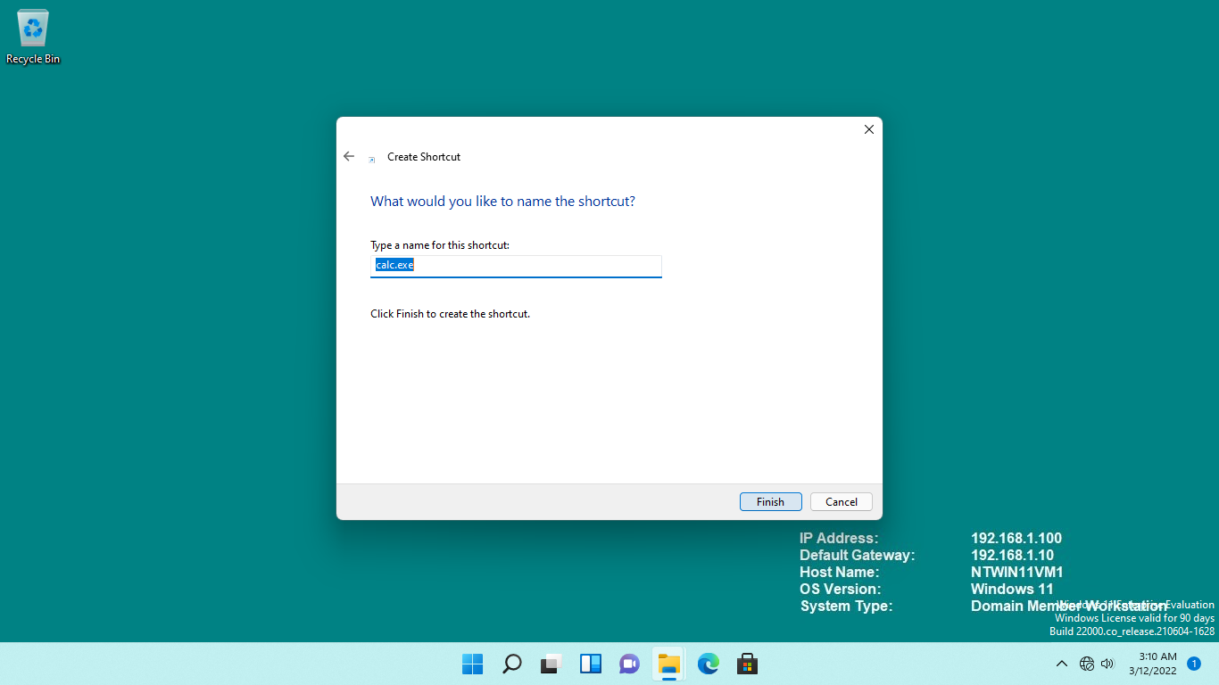

**Step 11:**

Close **File Explorer**.

To test the new programs added in the **Personal Startup** and **Common Startup** folders, you must sign out of the current session.

Right-click the **Start** icon, point to **Shut down or sign out** and select **Sign out.**

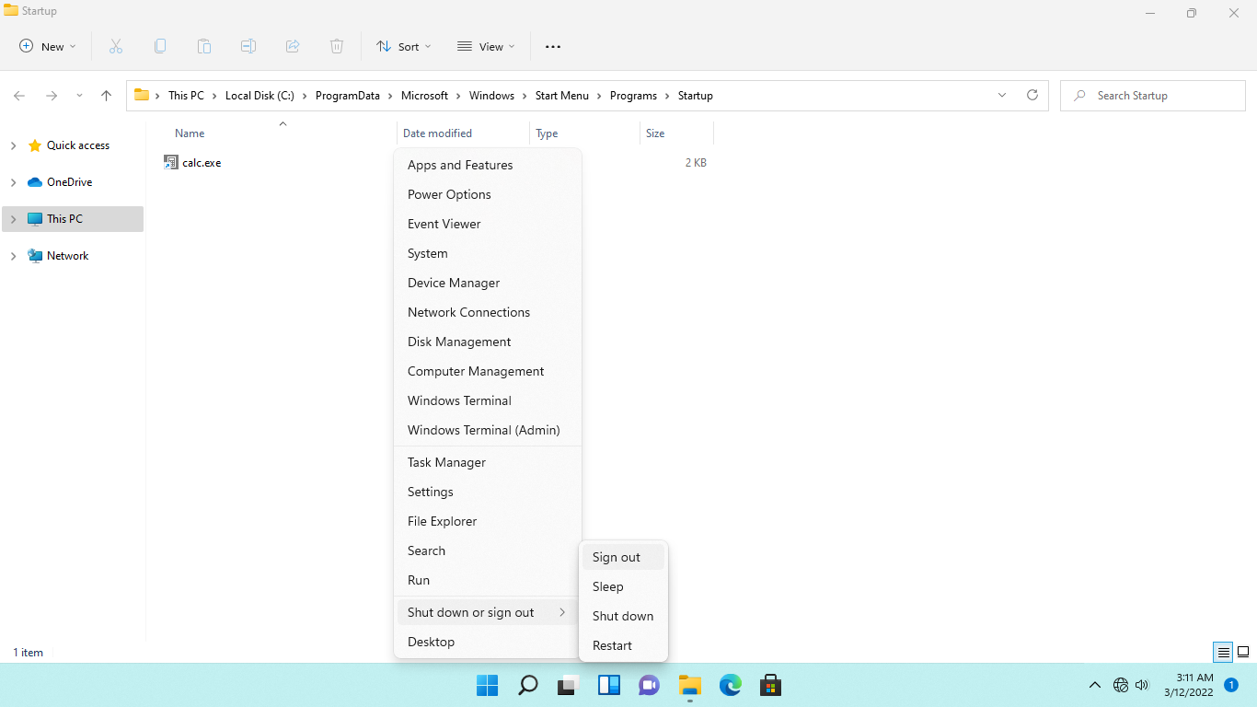

**Step 12:**

Reconnect to **NTWIN11VM1**.

You will be signed in automatically to **NTWIN11VM1** as before.

Notice that the Notepad and Calculator application windows are automatically launched as the program shortcuts were added to the Personal Startup and Common Startup folder.

After a few moments, the batch file will again display in the command prompt window.

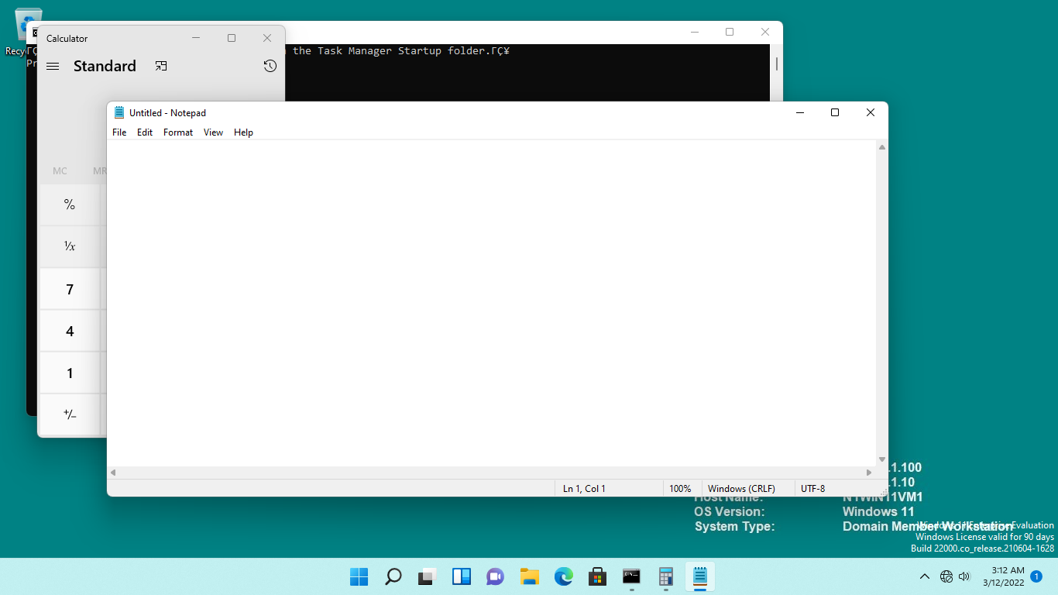

## **Task 4:**

For backward compatibility, Windows 11, like previous versions, supports hundreds of user programs, including older software. This does not, however, imply that practically all application types will run on the most recent version of Windows.

Some applications may not work properly owing to programming issues or a lack of updates to make them compatible with Windows 11.

In this task, we will download and run a utility that will create a scenario of an application with high CPU utilization in Windows - causing a bottleneck in the processor. You will use the Task Manager to identify and stop such applications.

**Step 1:**

On **NTWIN11VM1**, click **Microsoft Edge** on the **Taskbar**.

In the Microsoft official page, you can download [cpustres.exe](https://docs.microsoft.com/en-us/sysinternals/downloads/cpustres)

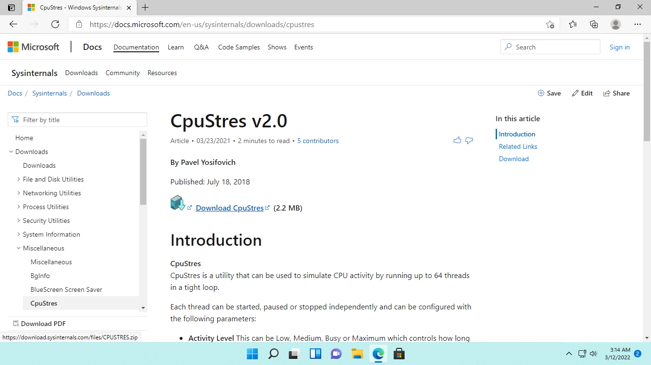

**Step 2:**

When the download is finished, it will appear in the **Downloads** popup window.

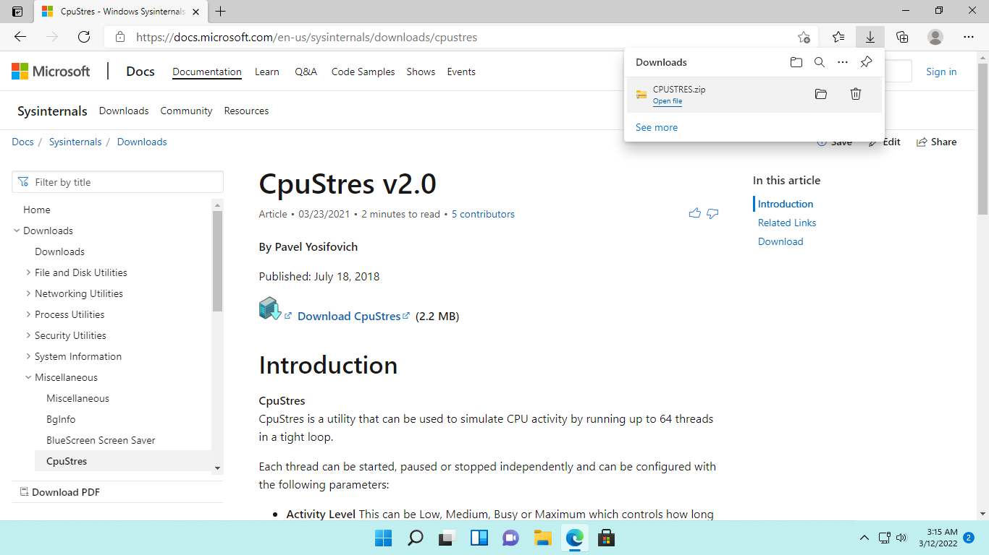

**Step 3:**

Click the **Open file** web link to open **cpustres.exe.** The **CPU Stress** window will appear.

On the **CPU Stress** window, Right click Thread **1**, change the **Activity** too **Busy** from the dropdown options.

Likewise, under **Thread 2, Thread 3**, and **Thread 4,** tick the **Active** boxes and change the **Activity** to **Busy**.

Keep the **CPU Stress a**pplication running.

|  |
| --- |
| **Note:** As a result of these changes in CPU Stress, the **NTWIN11VM1** device's CPU use will increase significantly. There will be some lag in the computer's response time. |

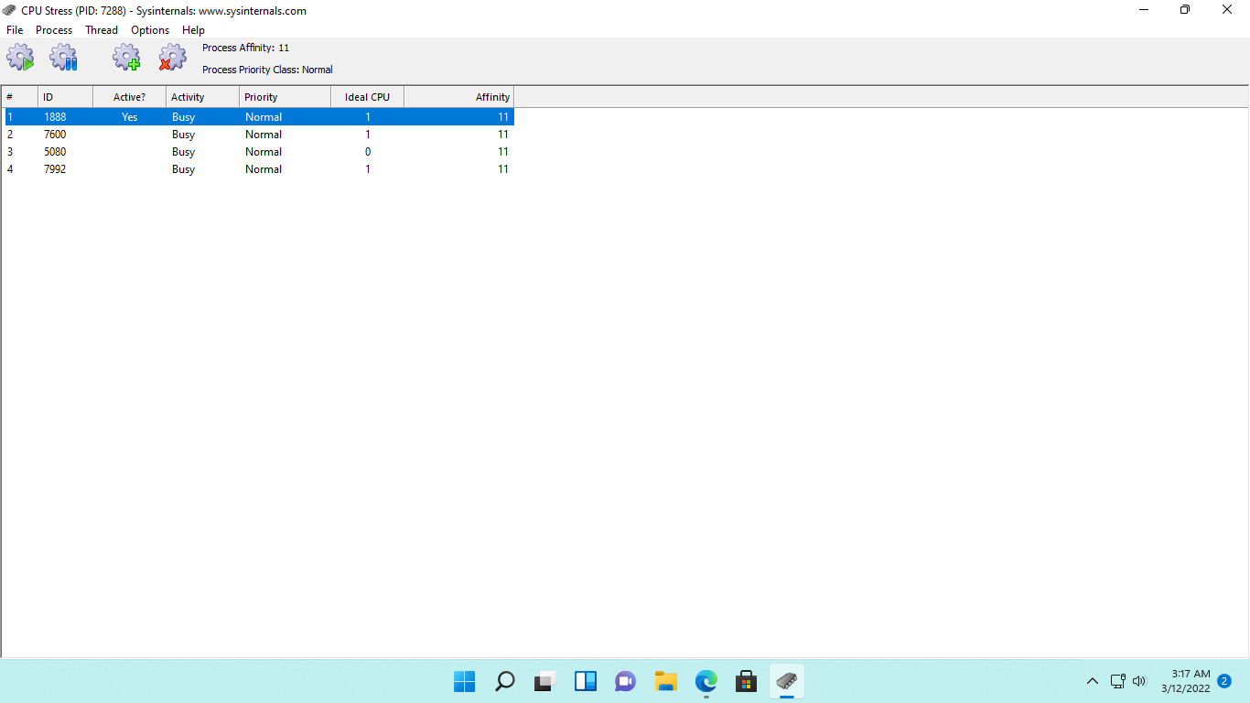

**Step 4:**

Right-click on the **Start** and select **Task Manager.**

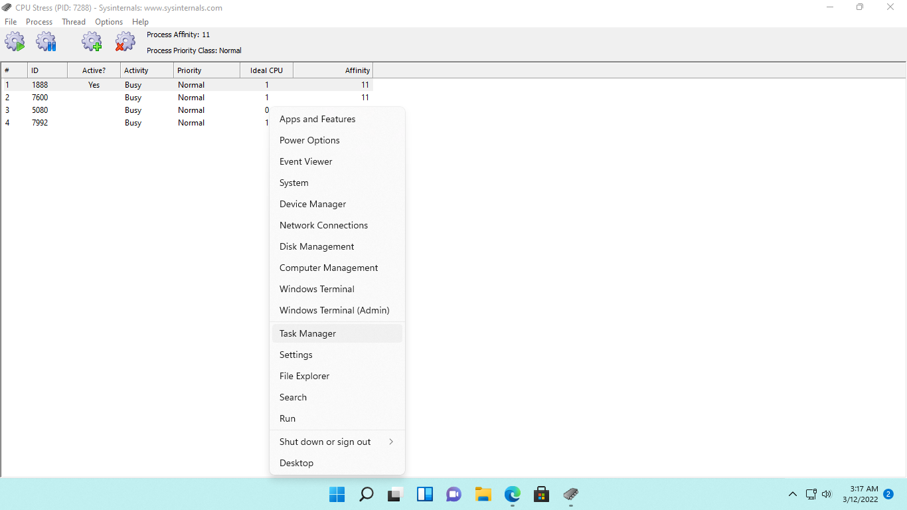

**Step 5:**

From the **Task Manager** window, under the **Processes** tab, notice that **CpuStrese MFC Application**…. has a fairly high CPU time allocated to it.

If the tabs are not displayed, you will need to click on **More details.**

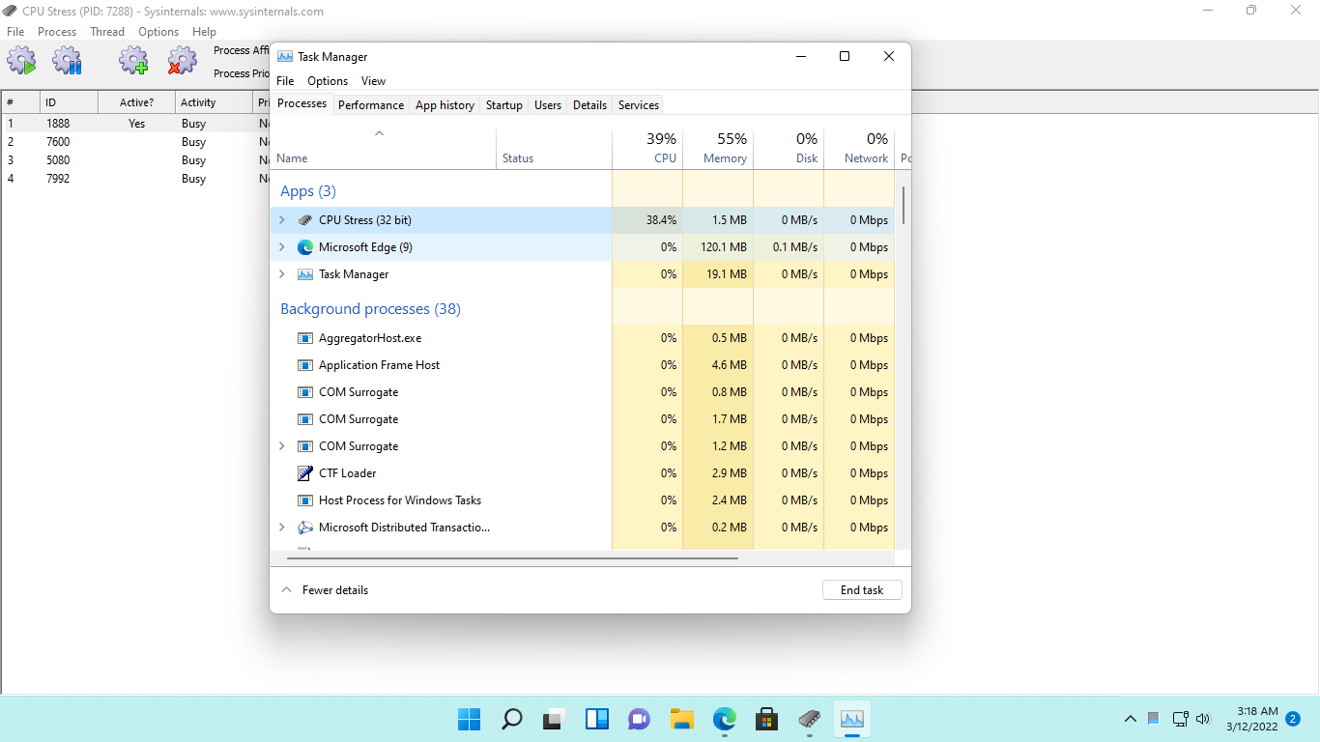

**Step 6:**

Right-click the **CpuStres MFC Application**…. and select **End task.**

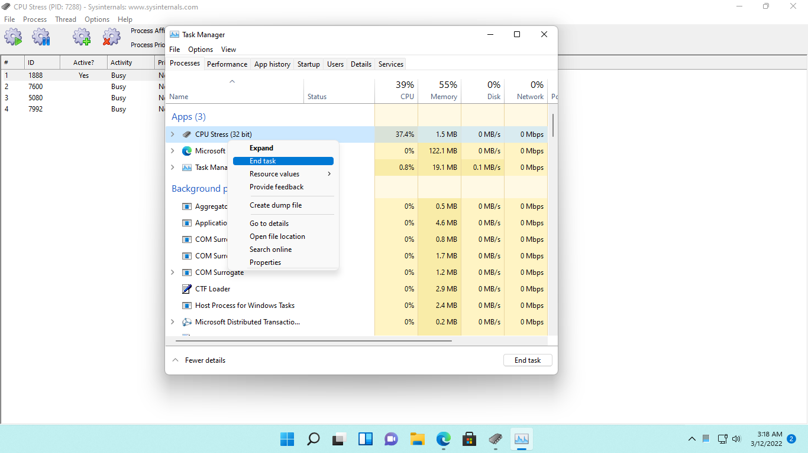

**Step 7:**

After closing the **CPU Stress** application through **Task Manager**, notice that the CPU utilization of the device has remarkably gone down.

Close the **Task Manager** window.

Likewise, close any other open windows.

